MyOS Design Considerations
(in no particular order)

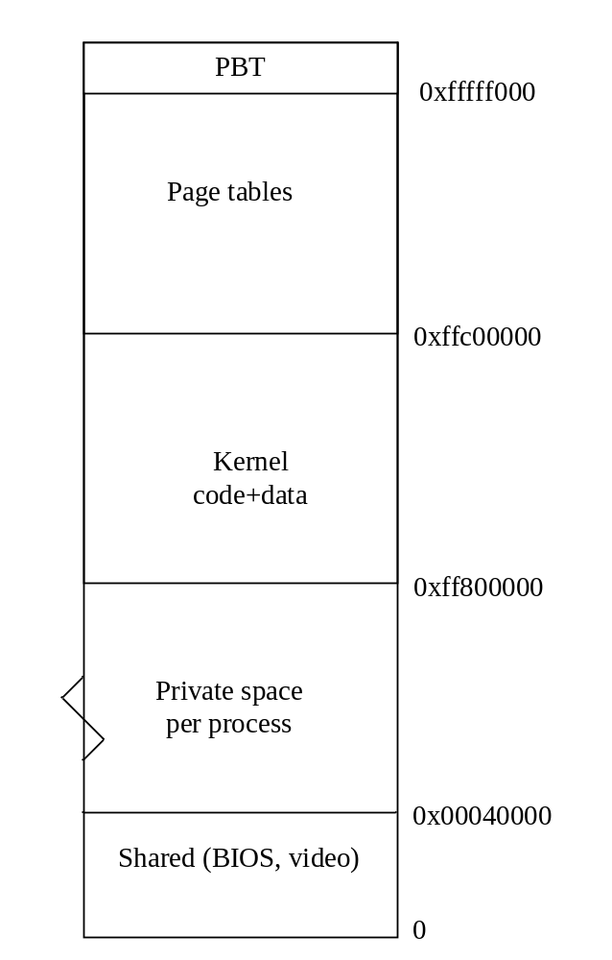Virtual Memory

The general memory layout of MyOS is shown to the right. The kernel is loaded in the topmost 8Mb of virtual memory, starting at address 0xFF800000. The last 4Mb of virtual memory are used for mapping the page tables, the last 4KB is the Page Base Table (PBT).

A PBT is allocated per process / task, all tasks share the same mapping for the upper 8Mb of memory (and, currently, the first 4Mb including video memory at 0xB8000 – this may be changed). The 2048 page table entries for the upper 8Mb (and the 1024 lower ones) are marked as global pages, ensuring that a task switch does not invalidate their cache.

Shared dynamic kernel memory for data (range 0xff800000-0xffc00000) can be allocated through the IVirtualMemory API, in small blocks. Allocation may trigger mapping of a newly allocated memory page (4K). Both implicit and explicit sizes are supported.

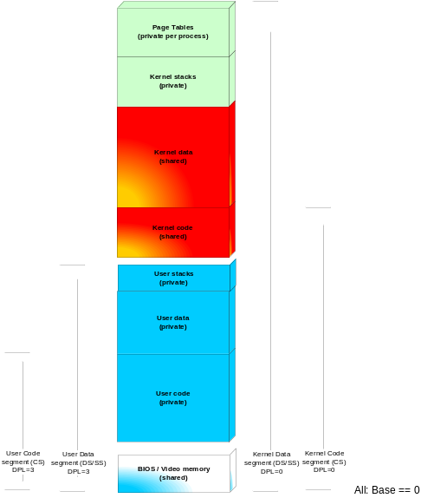
Figuur 1 New layout for better stack/data overflow protection

Interrupts

Hardware interrupts
Hardware interrupts are asynchronous, unpredictable events that typically need to be serviced immediately. The x86 architecture supports 256 interrupt levels, 16 (15 + 1 cascaded) of which are connected to hardware lines.
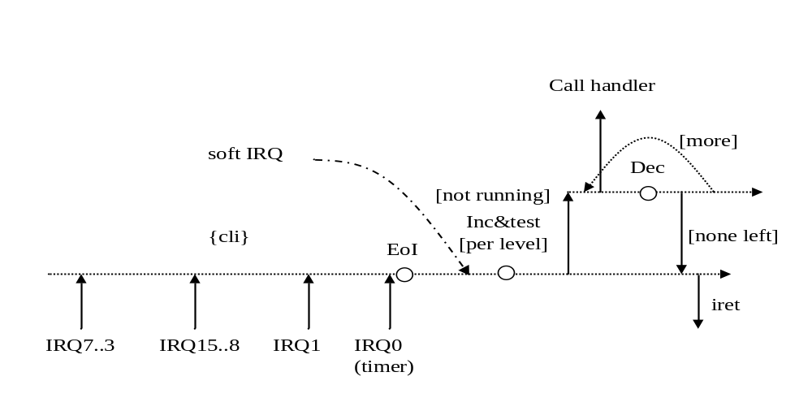
Figuur 2 Interrupt processing flow
Roughly the design is as follows: incoming interrupts (shown in order of priority, IRQ0==highest) are serviced with the interrupt flag enabled. They receive an end-of-interrupt immediately, and then a per-level counter (initialized to -1) is incremented. If the handler (per level) is not running, it is invoked. When it returns, a check is made for more pending interrupts, repeatedly until none remain.
This structure enforces mutual exclusion to each handler: at any given point in time, there is at most 1 thread of execution per IRQ level. The “inc & test” is performed atomically.

9/8/2008: The above design was updated, there is no longer a lock counter per interrupt. The reason is twofold: the OS should be able to deal with devices sharing an interrupt line (like for PCI), in which case their handlers should not be mutually exclusive. Also, handlers need to synchronize with code running in regular thread context anyway; the interrupt lock does not provide protection against that. There is now a counter to monitor the nesting level of interrupts, only at nesting level 0 time accounting is performed, and the thread scheduler possibly invoked if requested (since it should not be called with any locks held, or during nested interrupts).

Recent developments in hardware specs (PCI2.0/PCI3.0) have defined so-called message signaled interrupts (MSIs, see http://en.wikipedia.org/wiki/Message_Signaled_Interrupts). This is a mechanism by which the PCI device can be programmed to write a 16-bit (PCI2.0) or 32-bit (PCI3.0) value to memory, which then triggers an interrupt.

TODO: message signaled interrupts (PCI2.0/PCI3.0), emulate them also for regular line-based interrupts

Software interrupts
Software components of the OS can make use of the mutual exclusion (i.e. guaranteed serialized execution of the handler, including protection against intervention by interrupts of the given level). For example, the timer component issues a SoftIRQ(0) when modifying its internal data structures (timer priority heap).

Handlers
Since handlers are executed with mutual exclusion, a single flag bit in the handler suffices to indicate “in handler” versus “not in handler”. This helps to detect & avoid recursion, in case of callbacks into the handler code (e.g. set a timer from a thread’s onTimer() routine, already running as IRQ0)

Signals
Initially I figured I could design my OS without using “signals”, but there exists one common use case (killing a thread) that requires a facility to interrupt a thread by software. Signals co-exist poorly with the lock-based synchronization of timers, and I did not want to mask/unmask signals for each critical section (signals are expected to be rare). This weekend (17/8/2008) I came up with a design based on stack poisoning: replace the topmost return address on the to-be-signaled thread’s stack with a “processSignals” routine. That way, a thread has well-defined interruption points (call sites). Moreover, by checking call sites to be outside a “signal safe” linker section, critical code like the timer routines can be protected against interruption by signals (i.e. killing a thread which holds a lock is bad).

To look for the topmost safe call site, I scan for addresses in the kernel code space beyond the “signal safe” section and before the data section (see memory layout). Then, for a candidate return address, I check that the preceding instruction is a “call” (several encodings). This now seems to work like a charm; it provides zero overhead in the common case. Drawback: cannot easily protect dynamic modules in the same way (either exclude them totally from signal interruption, or fully reentrant).

Multi-Threading
MyOS supports multi-threading: multiple threads of execution can be created, each with their own private copy of execution state (i.e. CPU registers and stack). Each thread is associated with an address space (“Process”) which is active whenever the thread is executing. Threads can (temporarily) migrate to other address spaces.

Threads are scheduled by a scheduling policy that decides which thread(s) are running and how much quantum is assigned. The scheduler is invoked whenever an event occurs that affects the scheduling order:
- end of quantum timer (set for each running thread)
- end of sleep timer (set by sleep() call)
- wakeup() call from another thread
- sleep() or suspend() call for the current thread
- new thread created & ready for execution
- current thread exit

Basically: each time there is a transition in some thread’s state machine:
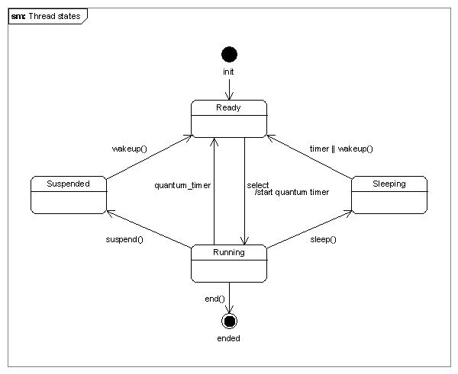
Figuur 3 Thread state model

State transitions
There are 2 types of state transitions: synchronous ( create(), suspend(), sleep(), wakeup() ) and asynchronous (timer). The latter execute at IRQ level 0 (and hence are protected against race conditions). To achieve the same for the synchronous transitions, a software IRQ0 is issued (by triggering the timer object associated with the thread).

Current thread
The current thread (per CPU) lives at a fixed offset in the stack page (denoted by the ESP register). At any given point in time, a reference to the running thread object can easily be obtained.

Idle thread
There is always 1 thread in the system that is guaranteed to be schedulable: the “idle” thread. This thread is created at bootstrap (1 per CPU), and turns into the idle thread after finishing initialization. It executes an infinite loop (could do “HLT” instructions for power-conscious systems).

The scheduler is aware of the idle thread, and is supposed to only select it when no other thread is ready for execution.

Thread creation & startup
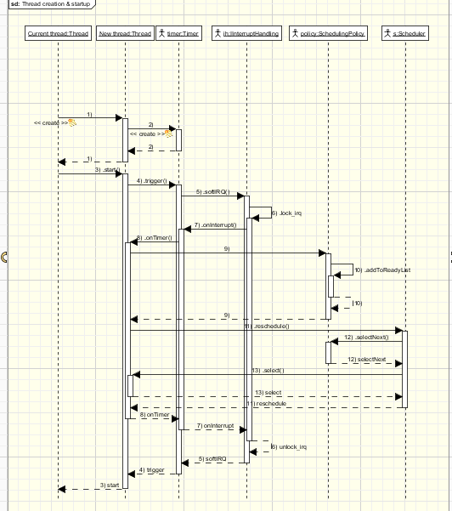
Figuur 4 Thread creation & startup
Thread startup is done by triggering the thread’s timer, such that the scheduling and switching (if any) can take place while protected against timer interrupts (step 6). When the call flow arrives at select() (step 13), there are quite some stack frames piled on top of each other:

Tabel 1 Stack upon select(13) (omitting local variables and some intermediate calls)
Return address Scheduler::reschedule
Return address Thread::onTimer
Return address Timer::onInterrupt
Return address IH::softIRQ
Return address Timer::trigger
Return address Thread::start

The key issue is to ensure that the timer irq is unlocked when the new thread starts running, such that its quantum timer (or any other timer that is sooner) can fire as usual. This can be arranged via a shortcut from Thread::startThread (i.e. call unlock there) but this is considered inelegant. Moreover, there are actually 2+n locks that need to be opened: one (or more, nested!) at the IRQ level, and one at the timer facility.

To solve this:
1. in initThread( part of start(3) ) the new thread’s stack is setup to contain the right parameters for a call to Thread::startThread (static starting routine for threads). The constructed stack frame matches the deconstruction code at the end of IH::IRQ handling (including “popad” & “iret”)
2. In onTimer(8) the top of the stack of the running thread is copied onto the newly created thread, from the top (minus local variable space) up to and including the return address for IH::IRQ (i.e. where onInterrupt(7) would return to).
3. The IRQ lock is undone
4. Upon “iret”, flags (interrupts enabled), code segment (including privilege level) and EIP (pointing to startThread) are restored. The parameters for startThread are in the registers, and the stack is aligned on 16 bytes (for efficiency).

Compiler interaction
OS development requires intricate knowledge of the compiler. Currently (29-8-07) using gcc 4.2.1. Some things to watch for:
- Different compiler flags generate different code; code that depends on offsets like thread stack manipulation may be affected
- MyOS uses exceptions, which means that the compiler may generate calls to
delete( void* ) operator, unless it knows the constructor does not throw any exception (?). It also means gcc specific exception handling code must be included (it may vary per gcc version)
- The linker script must provide a map how sections are placed. Naming conventions may change per compiler version
- Need to include sections for exception tables, virtual method tables, …

Interfaces & components
The MyOS mantra is “everything has an interface”. Interfaces are well-defined abstractions of functionality provided by components (coarse-grained objects with explicit dependencies). A component may provide more than one interface, but each interface type (identified by id) is exposed at most once. A component may be a singleton (i.e. one-of-a-kind) which implies its interfaces are also unique instances.

Components are aggregates of interface implementations, forming an implementation context for these interfaces. All interfaces are initialized upon component initialization. A component may provide a private heap of memory for the interface implementations to use, resulting in good locality of reference.

TODO: reference-count interfaces per usage, release components when all interfaces are unreferenced.

Users of an interface need not be aware of the component that is providing the interface, but can request a reference to it. Unique interfaces are registered in a global repository to support lookups; non-unique interfaces are registered in the same repository, using a hierarchical naming scheme (depending on the type of interface).

TODO: use <UUID>/instance, where UUID is the type id of the interfaces registered there (e.g. for thread instances, processes, …)

Core components
MyOS has the following structure of core components and interfaces:
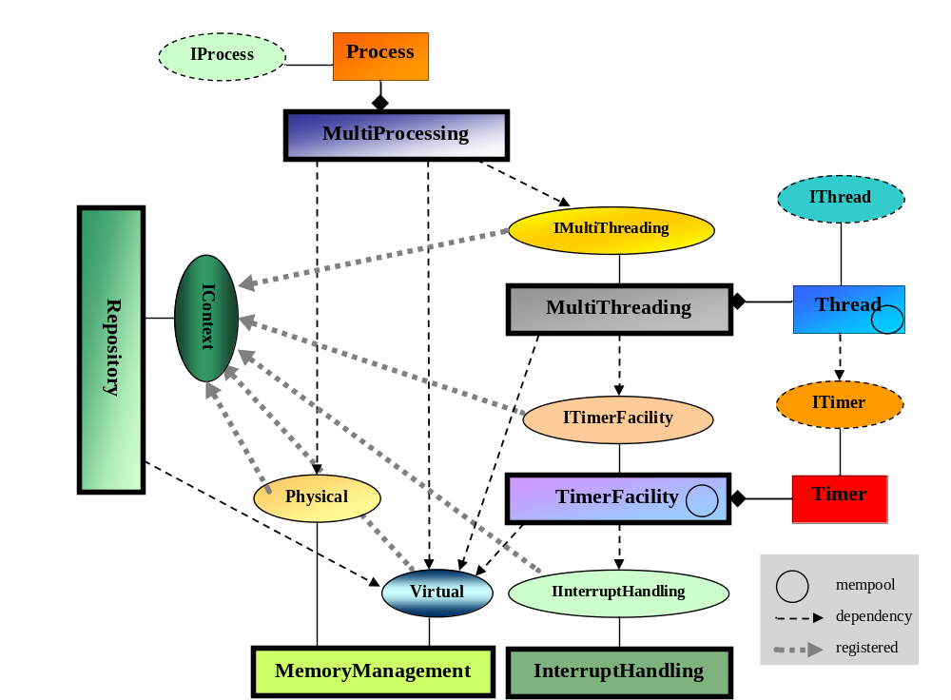Figuur 5 MyOS core components & interfaces

Note: IProcess not existing today

Structure of Memory Management code
Everything can be a Core::IInterface, but it sometimes results in awkward inheritance structures. There are at least two ways to define interfaces in C++ (structural patterns):
1) Using virtual methods as per Core::IInterface
2) Using namespaces to group regular C++ functions

Method (2) has the advantages of slightly less calling overhead, it works with traditional linking, and it avoids inheritance issues. Drawback is that multiple implementations of the same interface are more cumbersome (though the dynamic linker can help to “implement” multiple versions, but only towards external code).

Functional grouping of MM code
Manipulate page tables
Maintain list of free physical pages
Allocate kernel linear memory blocks
Allocate per-process private linear memory blocks
Handle page faults
Map memory I/O ranges
Reserve demand-paged memory (per region)
Allocate physical page(s)
Devices & drivers
IInterruptHandling
DemandPaging
FAT FS
ISO9660 FS
IDemandPaging

